Snow Day Work for Health

Pick two to do:

1. Using the portions from myplate (picture below) as a guide, make a yummy meal with your family, try to get something from each food group. If you don’t have, or don’t eat one of the food groups just use as many as you can.

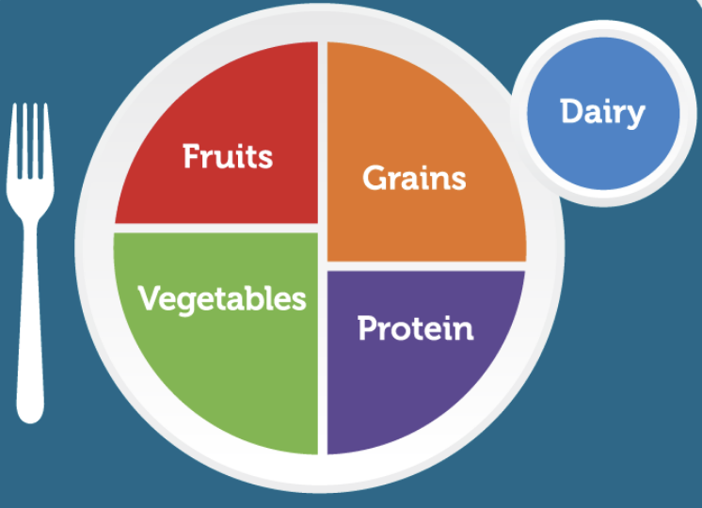

Remember lots of foods have more than one food group in them.

1. Move your body in a calming or joyful way. This could be playing outside, stretching, or dancing in your kitchen. Just get up and moving and make it fun!
2. Fire Safety:

Use a piece of paper to draw a floor plan of your home, find all the exits you could use in case of a fire.

-If your family already has a fire safety plan go over it together either by talking about it, or do a practice fire drill together.

-If you don’t have a fire safety plan, see if you can come up with answers to these questions:

* Where is our meeting place in the event of a fire?
* Which neighbor can we ask to call the fire department if we don’t have a phone?
* Do we have a neighbor who will let us wait in their house if we have a fire in the winter?